Christina Copeland Joe Regenstein
ALS 477 Term Paper May 21, 2008
“Efforts to Raise Awareness about the Unsustainability of Bottled Water and Reduce its Use on Cornell’s Campus”
ABSTRACT

I have been working on a campaign to raise awareness about how unsustainable bottled water is for the environment. Large amounts of bottled water are a commonplace sight, not only on college campuses, but increasingly in American workplaces and homes as well. This is an unnecessary and unsustainable practice; unnecessary because there is potable water coming out of our faucets in every building, and unsustainable because of the amount of resources and waste intertwined with one-time use plastic bottles. This semester I have challenged the idea that many people have that bottled water tastes “better” than tap water by holding “Tap Water Challenges,” where volunteers evaluate unidentified waters. Using test samples of tap water that was filtered with a Brita, unfiltered tap water, Poland Springs water and a supermarket brand of “Spring Water,” there was no preference for bottled water over tap; in fact, looking at data from Cornell’s campus on 4/11/08, approximately 40% of testers slightly disliked Poland Springs, almost equal to the number of people who liked Poland Springs either slightly, moderately, or very much (42% all together). Education about the unsustainability of bottled water is also an important aspect of the campaign. I made five signs with key facts about bottled water along with a campaign logo, as well as a larger informational Power Point poster for distribution toResident Assistant’s (RA’s) on North Campus to put in residence halls. I have been attending the Student Assembly Environmental Committee, requesting that they pass a resolution supporting the campaign. There is one thing that is clear: the world must move towards a more sustainable and reusable way of living, and one of the best tools we have to encourage that change is through education. This spreading of information and educating the public about the unsustainability of bottled water is one such effort.
DISCUSSION
Currently, the world needs to move towards a more sustainable way of living. A common aspect of unsustainability in the West is our “throw away” mentality, and bottled water is a poster child for this mentality. It is an item that is meant to be used once, for a short period of time (probably less than 24 hours), before it is discarded. While this throw away mentality also applies to other bottled beverages such as soda, I chose to focus on bottled water because it has such an easy alternative – tap water. It is easy to use a reusable container and fill it with tap water, whereas that is not the case for other bottled beverages such as soda, which don’t have a municipal distribution system. America, along with most developed countries, has safe, potable drinking water coming out of faucets in practically every building. While bottled water is growing in popularity, it would not be difficult to lower its use by a large percentage if it was used only in necessary situations.
There are several main areas in which bottled water is harmful to the earth, one of them being the use of fossil fuels in the production and transportation of bottled water, a problem seeing as fossil fuels are a nonrenewable energy source whose use contributes to climate change. The most commonly used plastic for making water bottles is polyethylene terephthalate (PET, recycling identification number 1), which is derived from crude oil (Owen, 2006). And nearly a quarter of all bottled water crosses national borders to reach consumers, burning fossil fuels as they are transported by trucks, boats, and trains (Owen, 2006). This statistic must be looked at carefully; my main argument is that bottled water is unnecessary in developed countries where there is the infrastructure to bring potable water nearly everywhere, but I realize that this is not the case in many developing countries, and that a quarter of the totals is accounted for by the bottled water shipped to developing countries. However, I do believe the statistic has some merit, since developed countries are by far the biggest consumers of bottled water. The U.S. is the world’s leading consumer of bottled water, and per capita, the largest consumers are Italy, Mexico, the United Arab Emirates, Belgium, and France (Arnold, 2006). French brands Evian and Volvic, bottled at the source and common in America, export between 50 and 60% of their water to destinations across the globe (Owen, 2006). To visualize the average energy cost of making the plastic, processing and filling the bottle, transporting bottled water to market and then dealing with the waste: it would be like filling up a quarter of every bottle with oil (Paulson, 2007). Practically all of our goods and services use fossil fuels, and to reduce our overall footprint (a measure of our demand on the Earth’s ecosystems and natural resources) we must lower the use of products that are unnecessary, which bottled water is in the Western world.
The second main feature of bottled water that is unsustainable is the waste that is produced, seeing as it has an extremely low usage time before it is discarded. In America, we went through about 50 billion plastic water bottles last year, which averages out to about 167 for each person (Fishman, 2007). On top of that, about “86% of plastic water bottles in the U.S. become garbage or litter,” according to the Container Recycling Institute in Washington DC; integrating that information with the previous fact, that means on average each American threw out 143 plastic bottles last year(Owen, 2006). And while recycling is good, that can also use a lot of fossil fuels; since the U.S. doesn’t have all the resources internally to recycle large quantities of these materials; of all the PET bottles that were deposited in the U.S. in 2004 for recycling, almost 40% of them had to be exported, some to as far away as China (Arnold, 2006). This recycling and waste problem is not specific to bottled water and applies to all bottled beverages, but again, out of them all bottled water is the easiest product to lower the use of, and it is clear that by not buying bottled water in the first place, less waste will be produced.
The final main unsustainable aspect of bottled water is the negative environmental impact bottling plants have on their surroundings. When bottling companies draw from the groundwater, water tables can be drawn down and aquifers depleted. Groundwater can be considered a nonrenewable resource because of the long amount of time it takes for an aquifer to naturally replenish. Plants often draw from municipal sources, but unlike municipalities and farmers, water drawn from bottling plants won’t be returned to its original basin, but will be bottled and shipped to the market (Ponzetti, 2002). In the U.S., where bottling companies may pump “up to 500 gallons per minute, or even more, out of each well, and many wells run 24 hours a day, 365 days a year (Howard, 2003),” there have already been court cases regarding bottling plants; many of them take into account the drying up of town wells once a bottling company comes, and as Save Our Springs president Terri Wolfe puts it, “The poor people whose wells run dry because of bottlers can’t afford that water (Howard, 2003).” When a water source is depleted, the water cycle of the ecosystem is negatively affected. The bottling plants take advantage of a common good, at the expense to the environment and the other people who rely on that water source.
While it is clear that using a reusable container for water instead of buying bottled water is much better for the environment, there has been some concern lately about chemicals that can leach from reusable polycarbonate plastic water bottles, such as those made by the Nalgene company. There is evidence that polycarbonate plastics, which fall under the recycling identification number 7 (clear Nalgene bottles) leach bisphenol – A (BPA), an endocrine disrupter that mimics estrogen. Polycarbonate plastics will leach when they are exposed to extreme heat (such as boiling water) or when they become old and the plastic starts degrading (Arsenault, 2008). And there is “circumstantial evidence” linking aluminum with Alzheimer’s disease; while “no causal relationship has been proved,” aluminum is not a good choice for a reusable container (“Aluminum and Alzheimer’s Disease” 2002). But a concern about certain reusable containers is not a reason for people to buy bottled water instead, since there are containers that do not leach anything. These include stainless steel bottles, such as the brand Kleen Kanteen bottles, and polyethylene plastics, which are marked as number 1 (PET), 2 (HDPE – High Density), and 4 (LDPE – Low Density) (Arsenault 2008). There is also a BPA free plastic called Tritan, which has been used in new bottles by the brand Camelbak. Tritan underwent “rigorous third party testing” to determine its safety (camelback.com). One must be cautious about what they use for a container, but the fact that polycarbonate and aluminum bottles may be a health risk should not drive people away from reusable containers.
CAMPAIGN ON CORNELL’S CAMPUS
While I believe that bottled water, and the topic of water in general, is something that needs to be addressed worldwide, my awareness campaign focused on Cornell University. In the fiscal year 2008, Cornell will spend almost 100,000 dollars on bottled water (interview with Ed Wilson, Chair of the Green Purchasing Team). It was upsetting to see students returning from Target lugging bulk packages of bottled water, but I have always (perhaps optimistically) felt that if people are aware of a problem, they will do their part to try to remedy the problem. In other words, if the majority was aware of the detrimental environmental impact bottled water has, and also realized how much cheaper it would be for them to use tap water, then most would start using a reusable container.
Therefore, the main component of my campaign was educational, in the form of informational posters. I made five different signs with key facts about bottled water and a simple campaign logo, printed on 8.5 by 11 sheets of paper to put up around campus. The first sign consists of a news excerpt about how Aquafina and Dasani are bottled tap water, the second compares how much the world spends on bottled water each year (100 billion dollars) and how much it would cost to halve the amount of people lacking sustainable access to potable water by 2015 (15 billion dollars). The rest of the signs show facts about the fossil fuels and waste associated with bottled water, and how tap water is more strictly regulated than bottled water (tap water undergoes many more water quality tests than bottled water) (Natural Resources Defense Council, 1999). I also made a large informational Power Point poster, which I am hoping to enter in the RA poster fair, so RA’s can put the posters up in all the residence halls on North Campus (freshman residential halls). The five 8.5” by 11” signs are in the appendix.
The other main educational action I took was much more interactive; at events on campus, I have held several “Tap Water Challenges,” where volunteers tasted and rated four different samples of unidentified waters. The goal of the Tap Water Challenge (TWC) is to challenge the belief many have that bottled water tastes better than tap water. I had four different samples at each TWC: unfiltered tap water from a dorm on Cornell’s North Campus, tap water that was filtered with a Brita from a home in Collegetown, Poland Springs water bought in a gallon jug from Top’s supermarket, and a generic Top’s “Spring Water” brand of bottled water. Each type of water was given a random three digit identification code, and was kept in an unmarked pitcher (except, of course, for the code identification number) so people had no idea which water they were tasting. As people drank their sample from labeled cups, I had them mark how much they liked the water using a nine point hedonic scale (1 being “dislike extremely” and 9 being “like extremely”), and when finished I told them which code was which water. I found TWC’s to be a good way to get people involved; they were excited by the challenge, and those who usually drink bottled water were sure they would be able to tell a difference.
But the majority of people were not able to differentiate waters, and many commented that the test forced them to be “nit picky”, but there was really not a big difference at all. See Figure 1 for the results of two TWCs, one held on April 11 at the Cornell Entrepreneurship Event (33 testers), where I was able to have a table at the resource fair (indoors) since the event had a sustainability theme; the audience was about half Cornell students, and about half entrepreneurs who were mostly under the age of 30. The other TWC was held on April 22 for Cornell’s Earth Day celebration and was outdoors on Ho Plaza (52 testers). The results from the two were combined as seen in the spreadsheet. Comparing the three middle, most neutral choices for unfiltered tap water and Poland springs (which is where the majority of testers results were), people preferred the unfiltered tap water to Poland springs. For unfiltered tap water, 21% marked “dislike slightly”, 21% marked “like slightly”, and 15% marked “neither like nor dislike”, while for the Poland Springs, 29% marked “dislike slightly”, 18% marked “like slightly”, and 15% marked “neither like nor dislike”. Interestingly, people liked the unfiltered tap more than the tap water that had been filtered with a Brita; for filtered tap, 25% marked “dislike slightly”, 14% marked “like slightly”, and 22% marked “neither like nor dislike”.
However, looking at all the numbers in the scored tests, there was a preference for bottled water over tap water. To “score” the results, for example, the “slightly dislike” number was multiplied by one, and added to the “moderately dislike” number which had been multiplied by a factor of two, added to the “very much dislike” number which had been multiplied by a factor of three, which was added to the “extremely dislike” number which had been multiplied by a factor of four. This provides an easy way to compare the results. The unfiltered tap water had a score of -69/+60 (69 in the negative “dislike” range, and 60 in the positive “like” range), Poland Springs had a score of -37 /+80, the filtered tap water had a score of -63/+49, and the supermarket “Spring Water” had a score of -34/+100. This does show that overall there is a difference in taste between bottled and tap water with people preferring bottled water, but many participants told me that it was very hard to tell a difference, and they would not have a problem drinking any of the types of water. It also must be taken into account that the TWC’s were held in the spring, when the tap water in Ithaca tends to be the least “pure” since the bodies of water it is being drawn from (streams in the case of both Cornell (Fall Creek) and Collegetown (Six Mile Creek)) is experiencing runoff as all of the snow melts, requiring more intensive water treatment. That may be part of the explanation as to why people were able to taste a difference. While the compilation of data from the TWC does show that there is a taste difference between bottled and tap water, with a preference towards bottled, the exercise still played an important role in making people think about the difference between the two. I have hope – resulting from the conversations I had with many participants - that the majority decided that the taste difference between tap and bottled water was not enough for them to drink only bottled water.
Besides educating people about bottled water in the hopes that they will change their ways, I also worked to make actual policy changes that the University would be responsible for implementing. The best way I found to do this was to write a resolution regarding University related bottled water use for the Student Assembly, and hope that they pass it. I began by attending S.A. Environmental Committee meetings, and working with the chair, Ashley McGovern, on writing a resolution stating that the Student Assembly supports efforts to reduce bottled water usage on campus (see appendix). Ashley suggested that I not submit the resolution until next fall, because if I submit it now and it gets passed, most people will forget about it over the summer, so this campaign will continue on into next year.
Another opportunity for the coming years that would be a great area to focus my bottled water campaign efforts on is Slope Day, a Cornell tradition on the last day of classes where there is a concert, and many of the student attendants are drunk. Cornell buys bottled water in bulk to distribute to the students in the hope of keeping them hydrated and avoiding alcohol poisoning. It is, of course, very important that students be kept hydrated, but I want to explore possible alternatives to bottled water on slope day, or ways to cut down on bottled water usage. Cornell allots approximately five bottles per person, and during the event the slope is covered in empty bottles. I knew that I would not have enough time to make a major change for this year’s slope day because of time constraints, but it was important to put the idea out there so that next year they would have to be taken into consideration. There are several options I thought of as ways to reduce bottled water use on slope days.
One of the first methods would be to offer water, but not in bottles. Cornell has its own brand of bottled water, and it also produces Cornell brand apple cider, orange juice, and milk that it sells around campus in cardboard cartons. I propose that instead of putting water in plastic bottles, Cornell puts the water in cardboard containers, which could then be composted afterwards. The costs and logistics of this idea need to be researched, to do a critical analysis and determine its viability.
The most expensive (and probably sustainable) option would be to provide each student with a reusable container that they keep for the day, and could also keep using afterwards. This would also require setting up a way for many people to fill their bottles at once. I think the best example to look at for getting water to many people at once is large sporting events, where there are large troughs with many water fountains in it. For the current slope day system of giving people bottled water, volunteers walk around to the students and hand them the bottles. This interaction of a sober person with the student is very important, as it is a way to check in and make sure people are alright. To keep this interaction, it should not be left to the student to get up and fill their own water bottle; the volunteers could use water tanks that can be worn on their backs, similar to what firefighters use when they fight forest fires, except of course not with that amount of pressure or weight! Then the volunteers could go around and fill the student’s reusable water containers, if the student was not able to get up and refill the bottle themselves.
The final, and probably most viable, idea I have to reduce bottled water usage on slope day is to have a combination of bottled water, and water coolers where people can refill their bottles. In the current system there is no way for people to fill a reusable container with water on the slope, and they are forced to take the bottled water if they want to drink water. In the proposed system, people would be encouraged to bring a reusable container, and there would be water coolers or a trough system for people to fill them. This would save Cornell money by reducing the amount of bottled water they have to buy in two ways. First, there would be the savings from the people who would not need bottled water because they brought their own container. Perhaps there could be an incentive for people to bring their own container, such as coupons for food discounts at the event. Second, if the water coolers were set up in central places, people who did receive a bottle of water could refill their plastic one at the cooler, thus reducing the need for Cornell to buy five bottles for each person. While there would still need to be bottled water available to people who are in need of it and can’t walk to a cooler, the amount needed would be much lower. This would be a good transitional or experimental way to try to reduce the use of bottled water on slope day. Even if people didn’t want to refill the plastic containers of bottled water, a proportion of students (I’m sure most of the Natural Resources majors!) would be happy to bring their reusable container and have a place to fill it.
Reducing bottled water usage on slope day is a touchy subject, because it is so intertwined with student health. But bottled water was not widespread in the United States until the mid 1970’s when Perrier hit the shores of America, and people managed without it for many years before then. While slope day is just one event that is easy to focus on, to make a real change, reducing and reusing needs to become something people think about daily. A large majority of Cornell students, as well as people all over America, carry water around with them to drink throughout the day. By choosing a reusable container over bottled water, not only are they saving themselves money, but they are helping to save the earth. By holding tap water challenges, posting signs around campus, and making efforts to use bottled water more sustainably at public events, I hope to make people think twice not only about reducing their waste and reusing a bottle, but sustainability in all aspects of their life.

Figure One: Tap Water Challenge Nine Point Hedonic Test Results from Cornell University, 4/11/08 and 4/22/08
 | CUP 209 (unfiltered tap) | CUP 559 (Poland Springs) | CUP 818 (filtered tap) | CUP 415 (Tops generic water)
Dislike Extremely | 3 | 0 | 2 | 0
Dislike Very Much | 7 | 2 | 4 | 4
Dislike Moderately | 9 | 3 | 11 | 7
Dislike Slightly | 18 | 25 | 21 | 8
Neither Like nor Dislike | 13 | 13 | 19 | 16
Like Slightly | 18 | 15 | 12 | 18
Like Moderately | 9 | 17 | 11 | 15
Like Very Much | 8 | 9 | 5 | 16
Like Extremely | 0 | 1 | 0 | 1

APPENDIX
Draft of Student Assembly Resolution:
Subject of Resolution: Supporting a reduction in the amount of bottled water on Cornell’s Campus
Whereas, Cornell University should be making efforts, both large and small, to contribute to environmentally sustainable practices
Whereas, bottled water is provided by the University at many meetings and events, as well as to students at events such as Slope Day, and many students also buy bottled water themselves as an alternative to tap water
Whereas, bottled water is environmentally harmful, one reason being it produces unnecessary waste that could be reduced by encouraging the use of reusable containers and tap water
Be it therefore resolved that the S.A. supports efforts to educate the Cornell community about the unsustainability of bottled water, and supports researching and implementing alternative methods to bottled water for events such as staff meetings and Slope Day.
Respectfully Submitted,
Christina Copeland ‘11

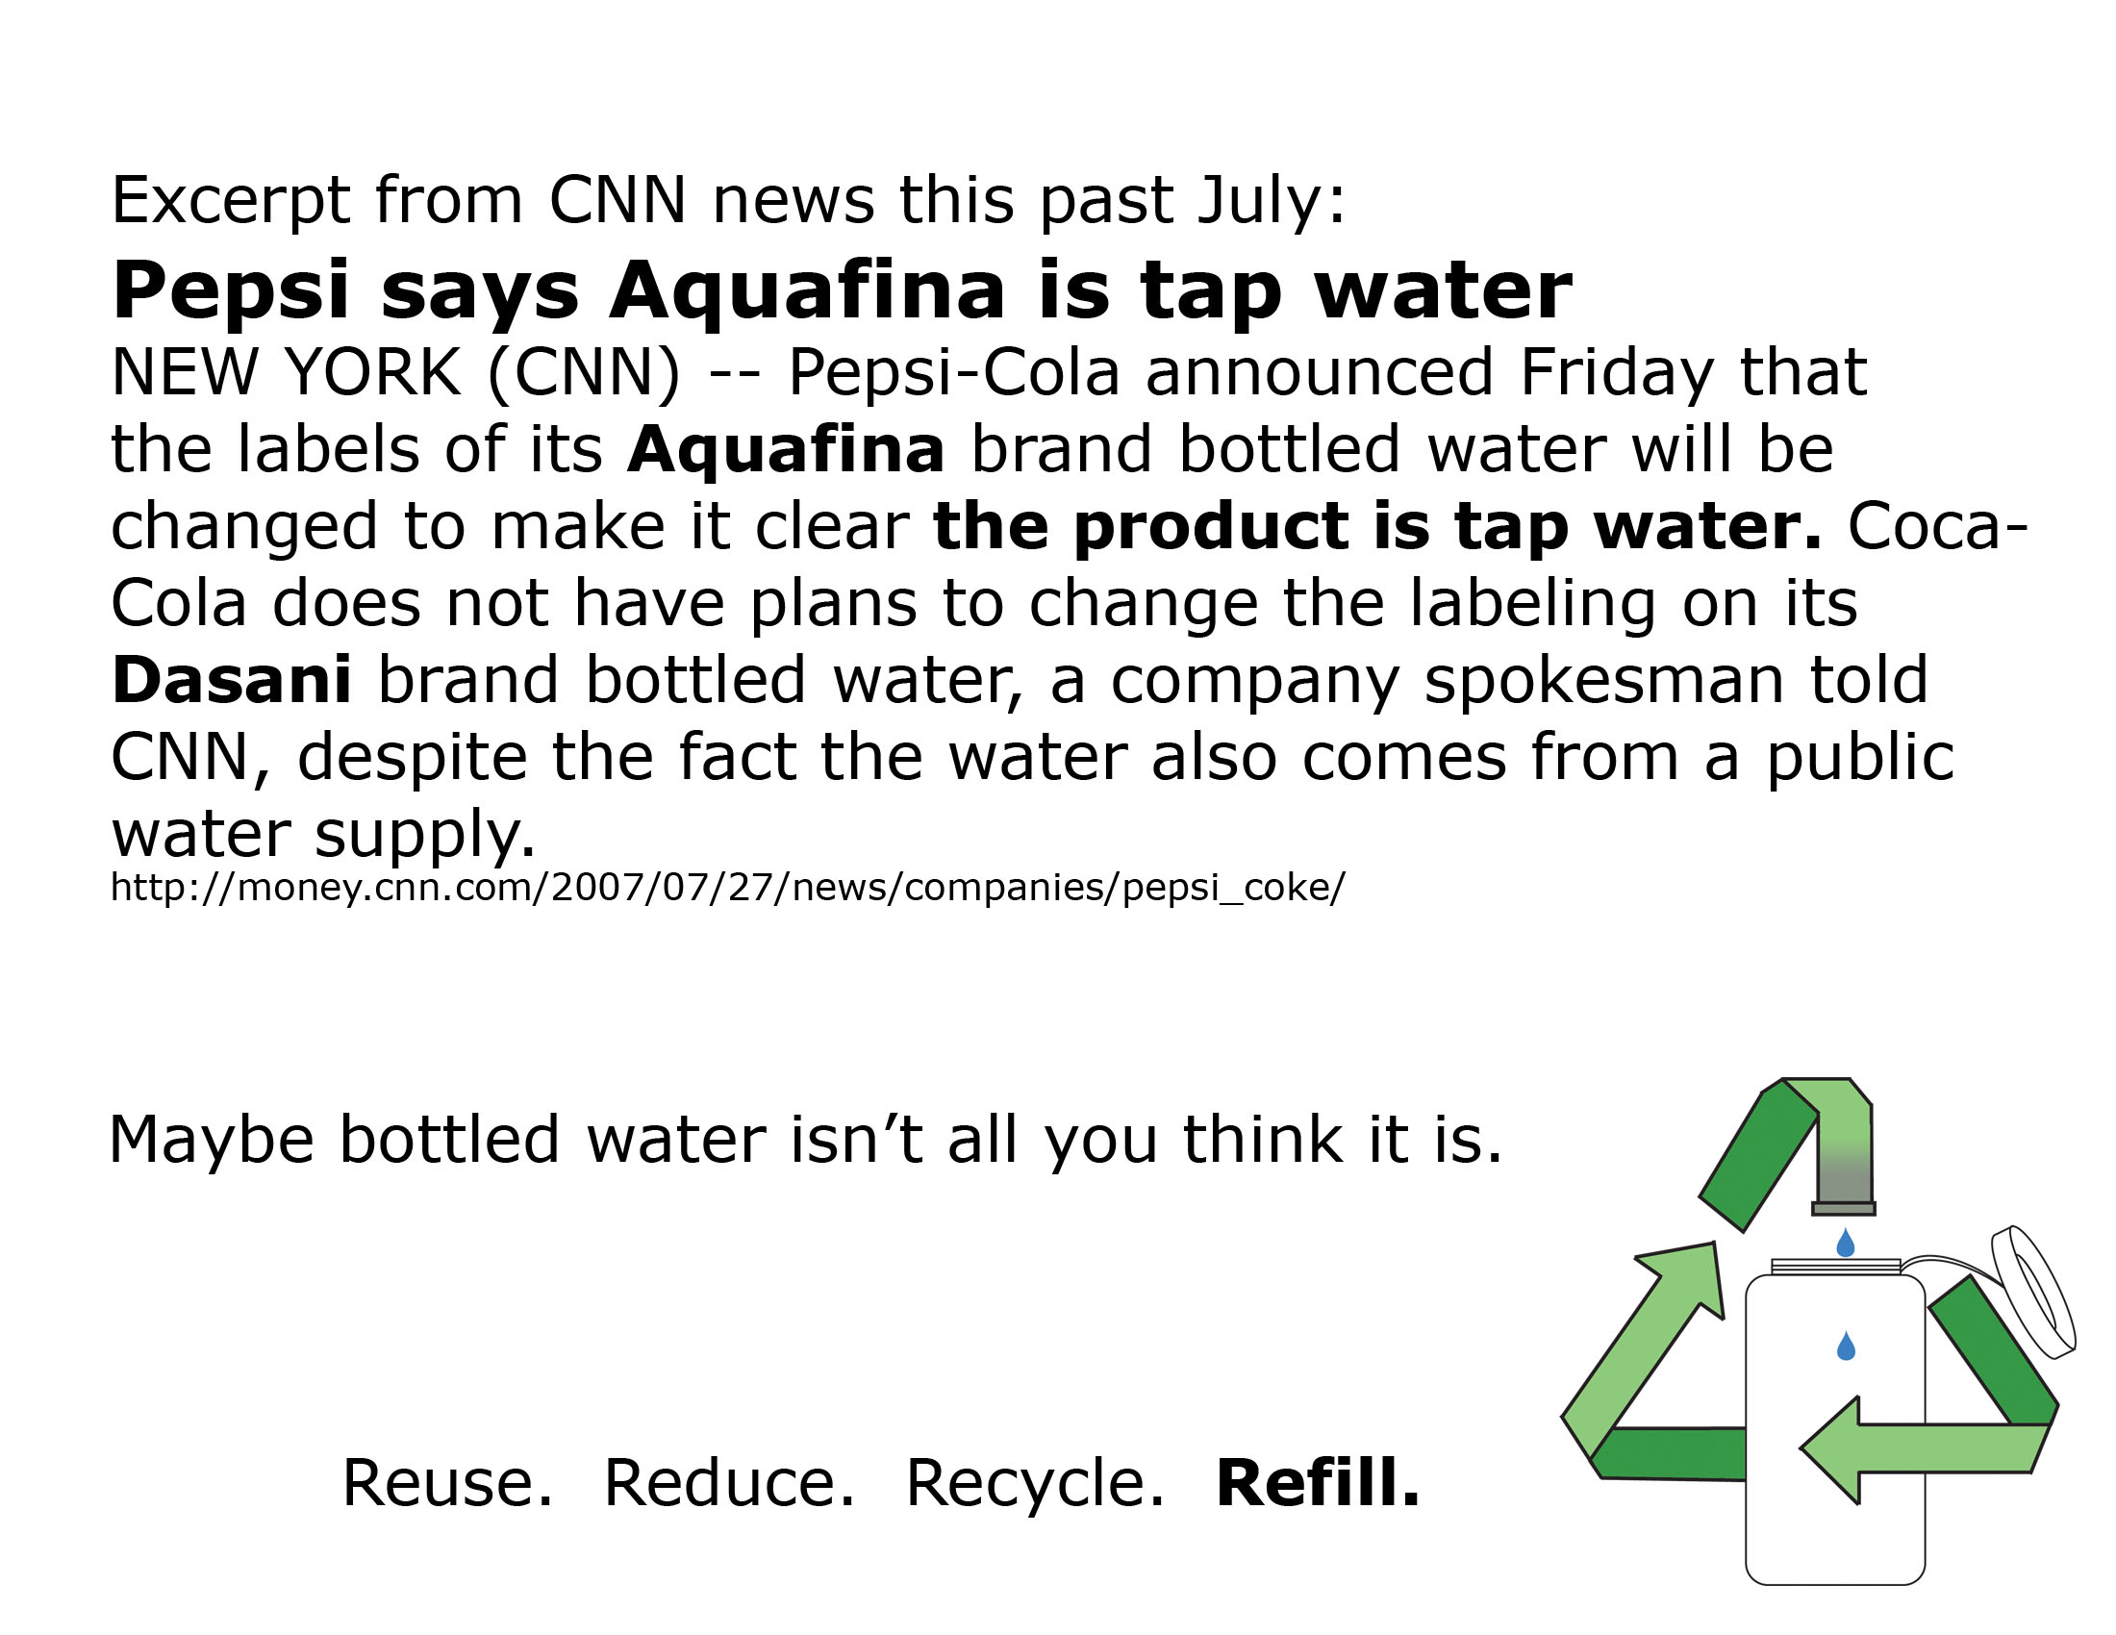

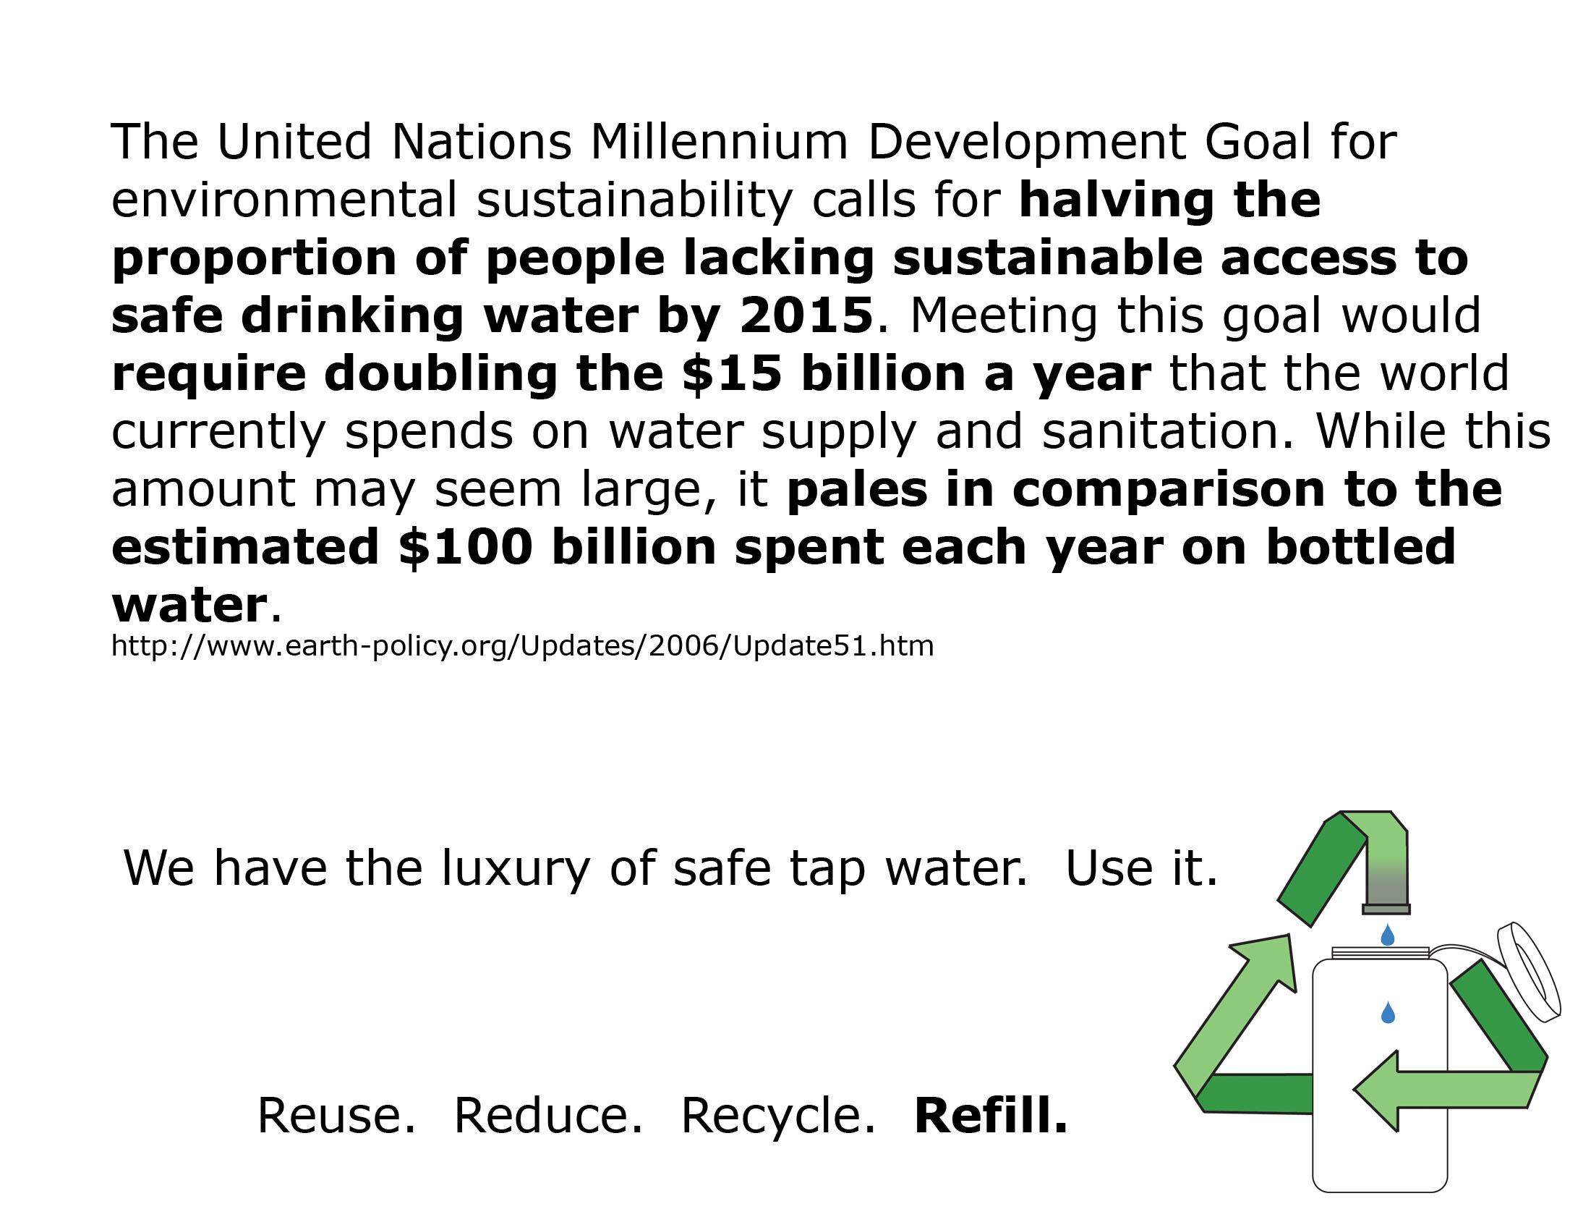
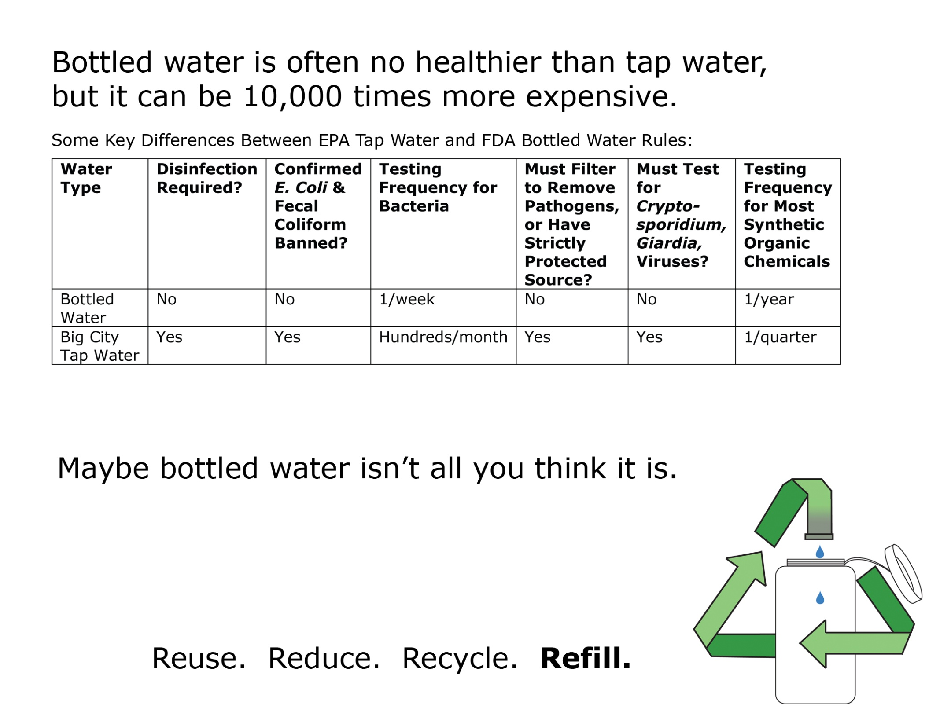
http://www.nrdc.org/water/drinking/nbw.asp
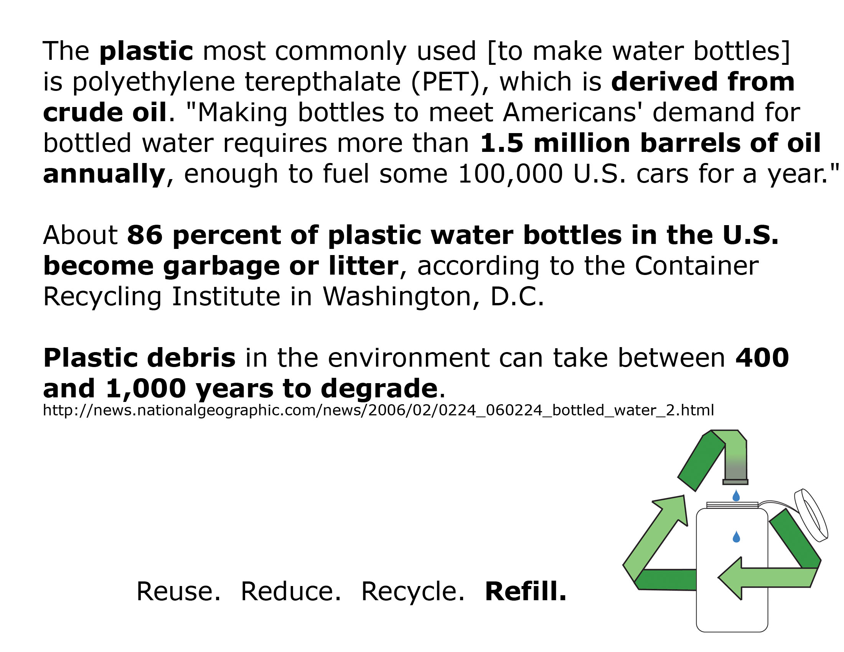

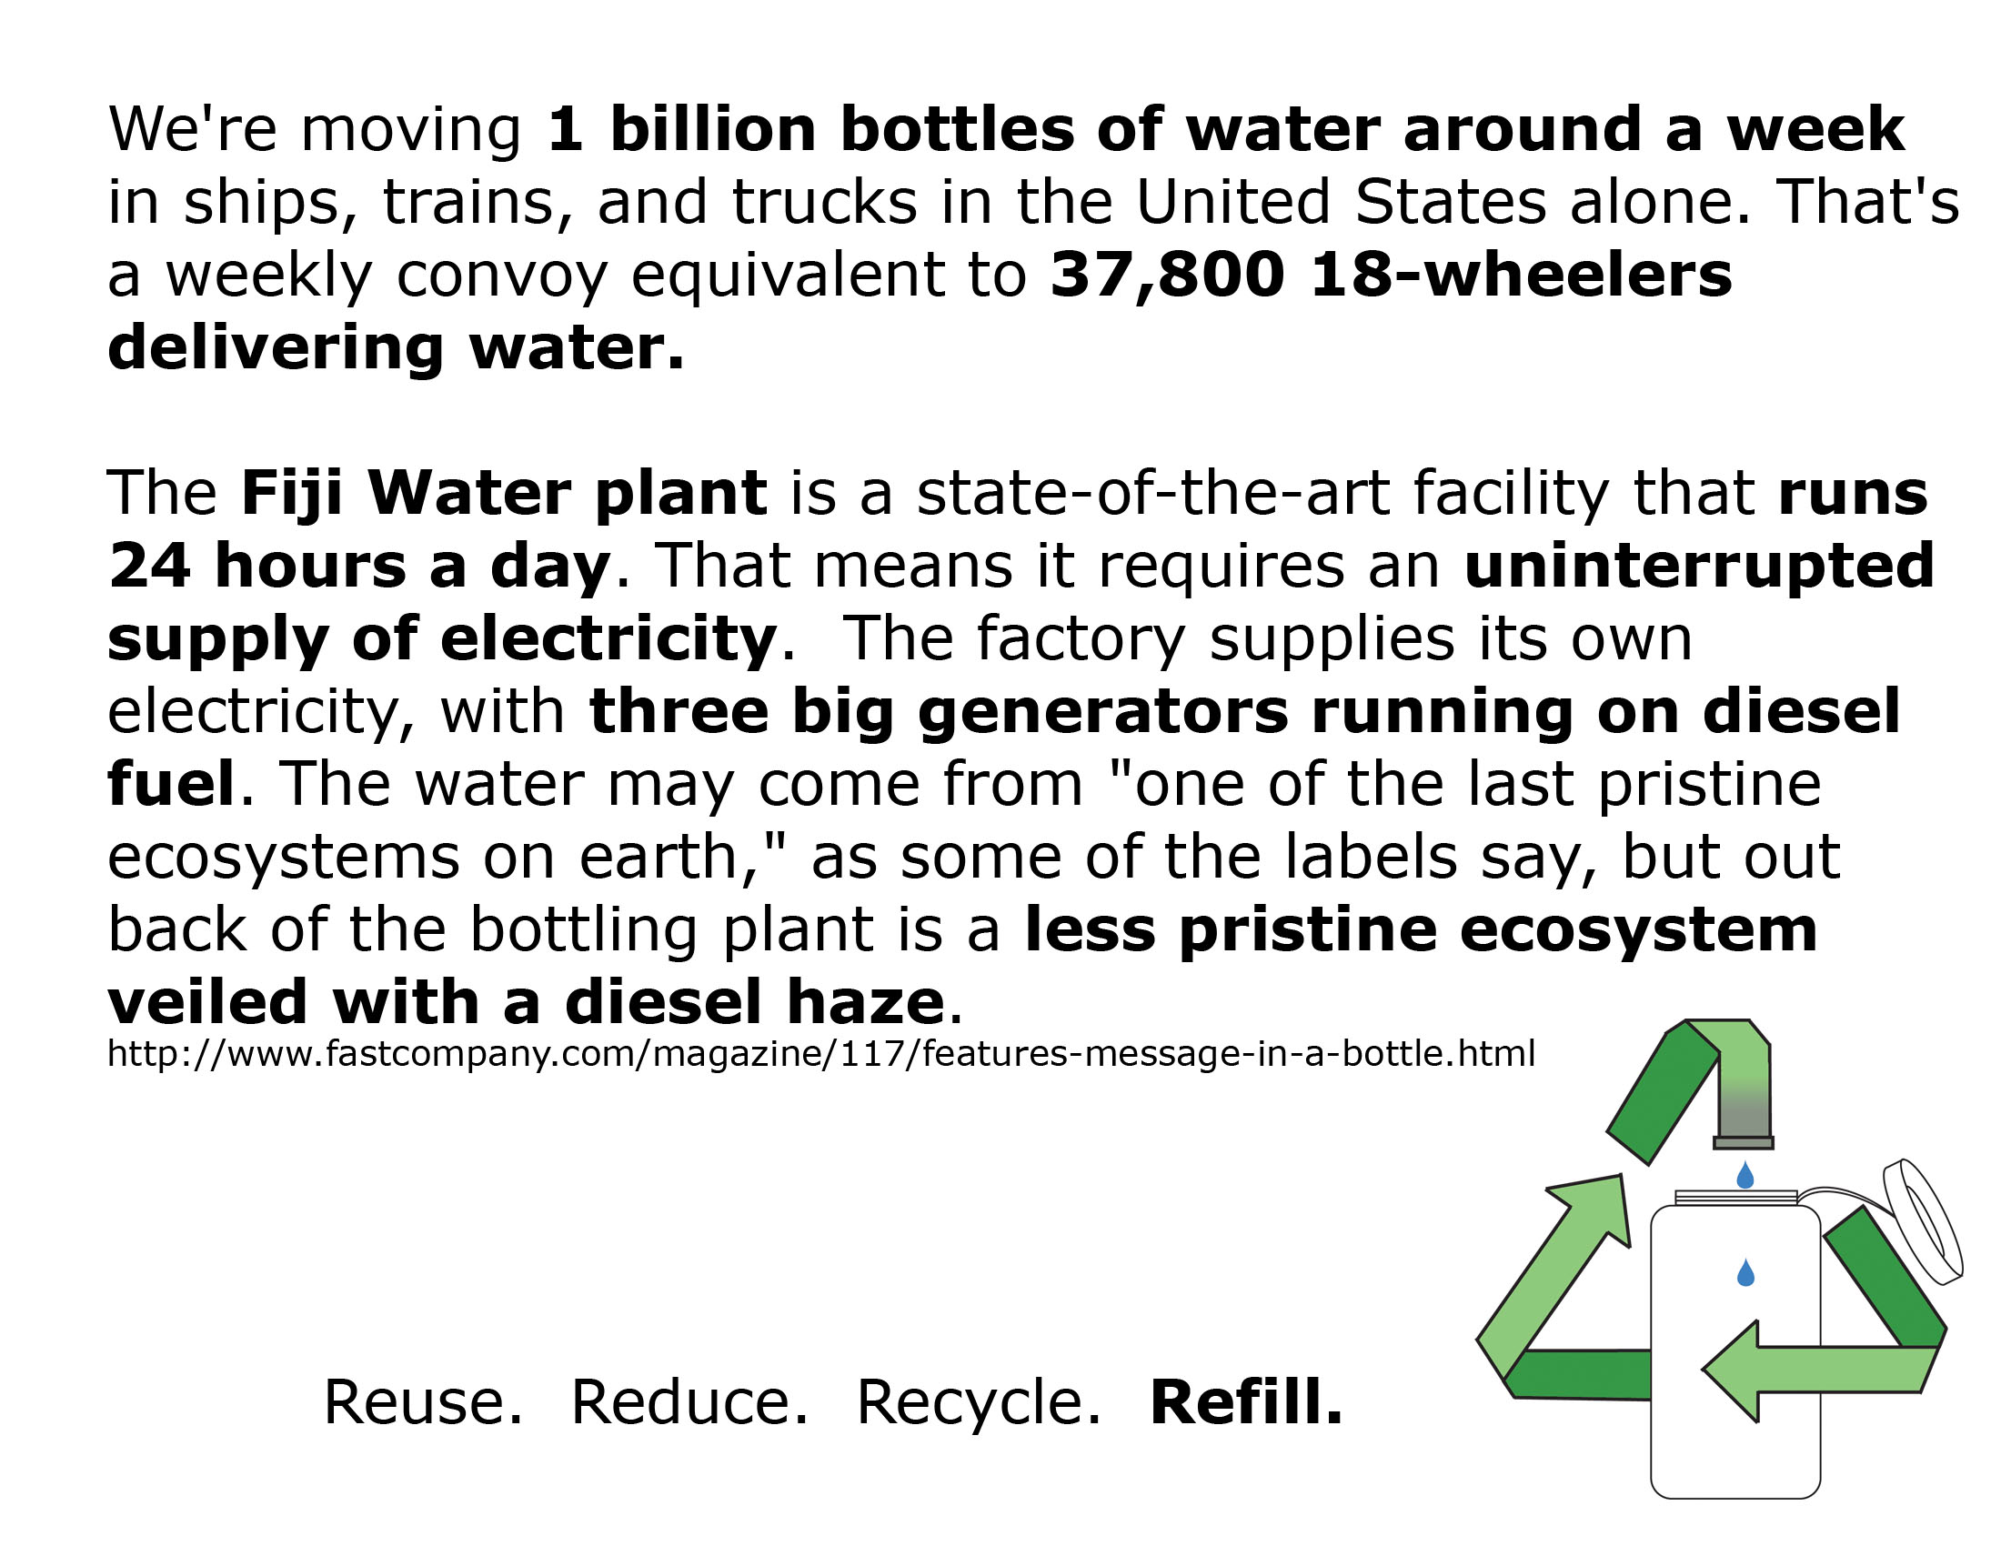

Works Cited
“Aluminum and Alzheimer’s Disease.” Alzheimer’s Society. June 2002. (Accessed 4/25/08).
< http://www.alzheimers.org.uk/site/scripts/documents_info.php?documentID=99>

Arnold, Emily. “Bottled Water: Pouring Resources Down the Drain.” Earth Policy Institute.
February 2, 2006 (Accessed 2/9/08). <http://www.earth-policy.org/ Updates/2006/ Update51.htm>

Arsenault, Carole. “BPA and Baby Bottles.” Environmental Working Group. February 14,
2008. (Accessed 4/25/08). < http://www.ewg.org/node/26034>

“Bottled Water: Pure Drink or Pure Hype?”. Natural Resources Defense Council. March 1999
(Accessed 5/25/08). < http://www.nrdc.org/water/drinking/nbw.asp>

Fishman, Charles. “Message in a Bottle.” Fast Company Magazine. December 19, 2007
(Accessed 2/10/08). Issue 117. <http://www.fastcompany.com/magazine/117/features-message-in-a-bottle.html>

Howard, Brian. “Message in a Bottle: Despite the Hype, Bottled Water is Neither Cleaner or
Greener than Bottled Water.” E/The Environmental Magazine. September/October 2003 Volume XIV (Accessed 2/9/08). <http://www.emagazine.com/view/?1125>

Paulson, Tom. “Thirst for Bottled Water may Hurt Environment.” Seattle Post Intelligencer.
April 19, 2007 (Accessed 2/9/08). <http://seattlepi.nwsource.com/local/312412_ botwaterweb.html>

Ponzetti, Pete. “Perrier Bottling Plant Wrests Michigan Water from Citizens.” Western Herald.
June 3, 2002 (Accessed 5/5/2008). < http://media. www.westernherald.com/media/storage/paper881/news/2002/06/03/Opini on/Perrier.Bottling.Plant.Wrests.Michigan.Water.From.Citizens-2126773.shtml>

Owen, James. “Bottled Water Isn’t Healthier Than Tap, Report Reveals.” National Geographic
News. February 24, 2006 (Accessed 2/10/08). <http://news.nationalgeographic.com/news /2006/02/0224_060224_bottled_water.html>

“The CamelBak Better Bottle FAQ’s.” ( Accessed 4/26/08).
<http://www.camelbak.com/bottles/pdfs/bpa_bottles_faq.pdf>

